Unit Test case 1.1 User Log-in Page:

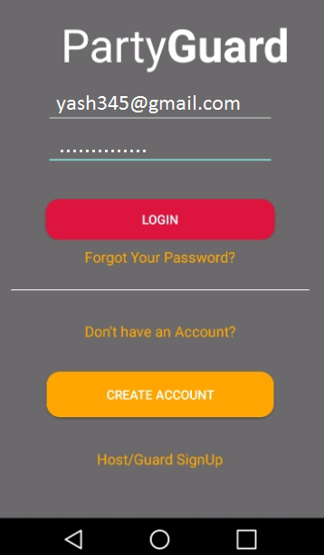

Unit Test case 1.2: User cannot log-in if user does not enter password.

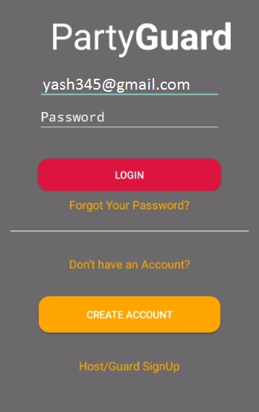

Unit test case 1.3 : Reset password

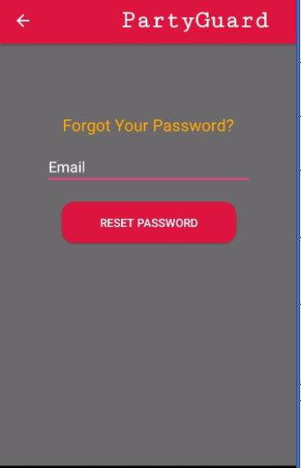

Unit test case 1.4 Validation while registering as a guest.

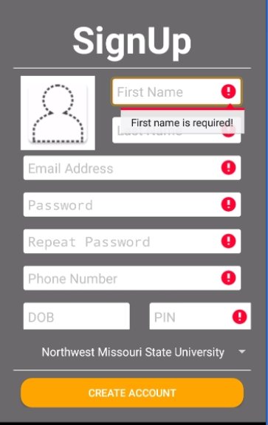

Unit test case 1.5: Host user log in

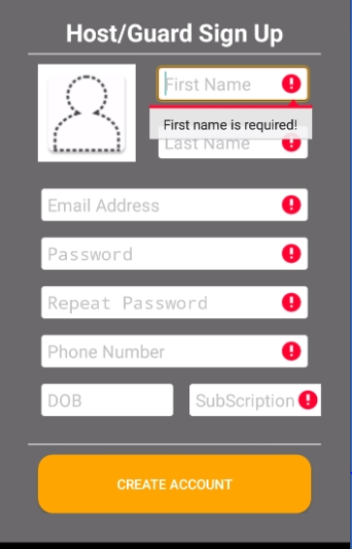

Unit test case 1.6: University selection

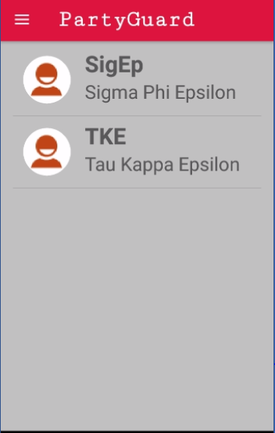

Unit test case 1.7: Fraternity is shown on top of the page along with issue types

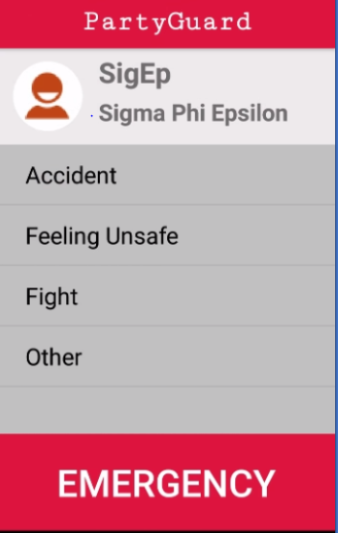

Unit test case1.8 : Fraternities in the locations are populated

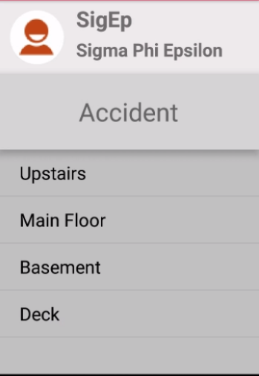

Unit test case 1.09 :Alert message to confirm the incident

